Program Structures and Algorithms

Spring 2023 (SEC—8)

NAME – Abhinav Ankur

NUID – 002747605

**Task** –

Your task is - Implement height-weighted Quick Union with Path Compression.

**Part 1(a)**

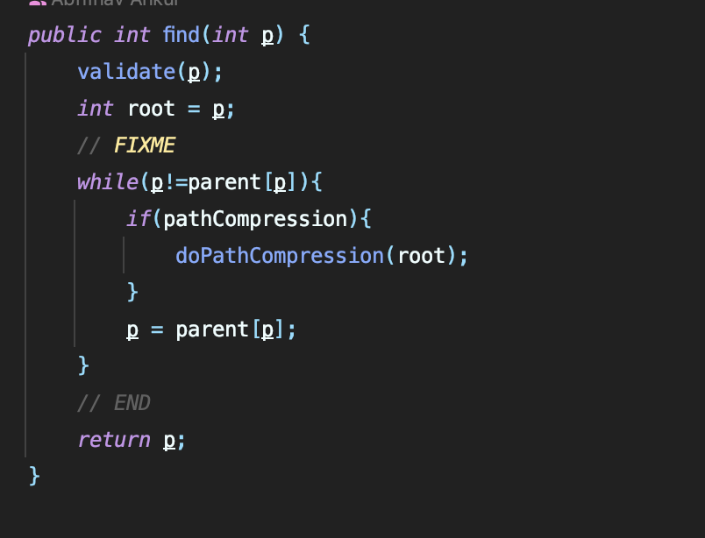

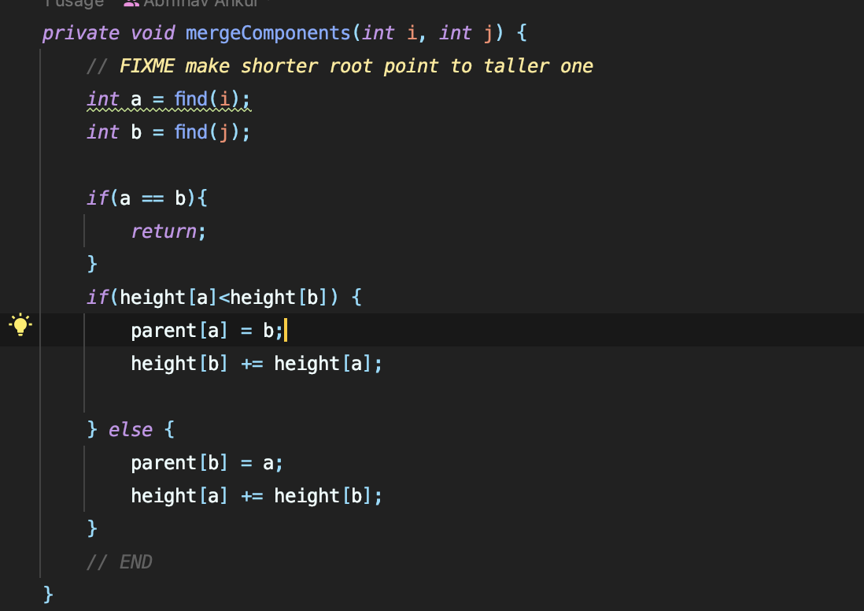

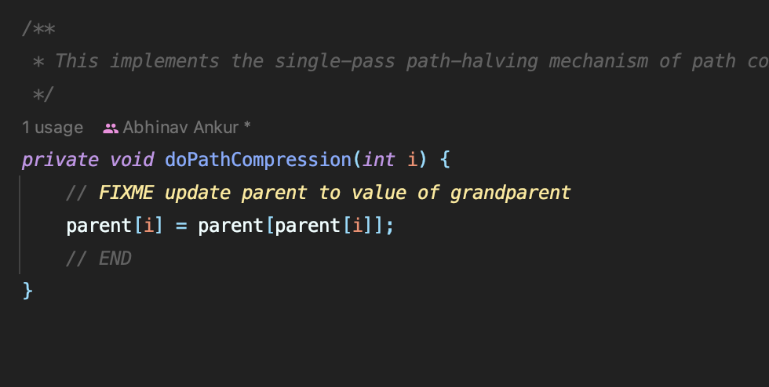

Part 1(b)

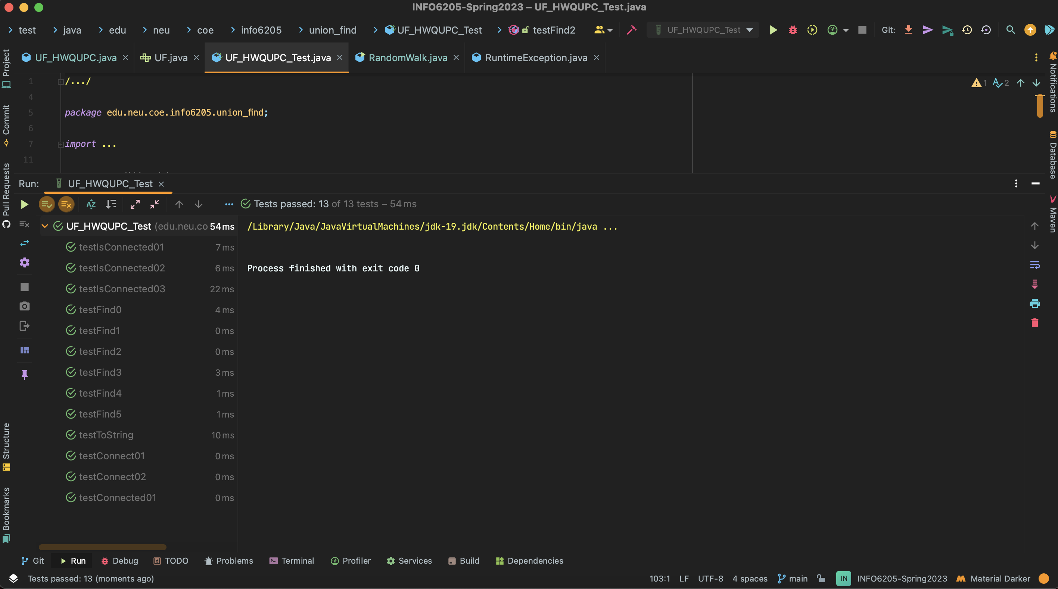

2

3 Relationship

From the above results we can conclude that

M = ½(n*ln(n))